 |  | September 2026
Activities in September  It’s September already, and we are turning our minds towards Fall, and soon, the Holiday Season. Oh my, where has the time gone!  This September we have so many opportunities to get out and get engaged in our community.  If an outing is what you’re looking for, there are a few to choose from. It’s apple season- so it’s time to visit Walter’s Fruit Ranch at Greenbluff. They offer an adorable farm store and eatery, as well as fruits and vegetables galore for the choosing.  Want to do a little shopping? Well, take a trip to a new store close to Valley Mall, 5 Below, where most items are $5 or less. Even better, another popular shopping destination, Hobby Lobby, is close by too.  Entertainment is the name of the game in September. Starting out the month is the Model T Car Show hosted by the Auxiliary volunteers. Love dogs? Check out the Ruff Revue dog trick show coming to the Community Center to entertain you with their dog and human tricks. Then, towards the end of the month we have another resident guitar concert from Ben A. with familiar tunes that’ll make you want to move to the beat.  As always there are multiple opportunities to get involved around campus. From BINGO! and clubs, to exercise, shows and socials, there’s something for everyone. I encourage you to get out & about in the cooler weather that September has to offer. Check your activities calendar on the back of this page for dates, times and locations of all activities. See you soon!  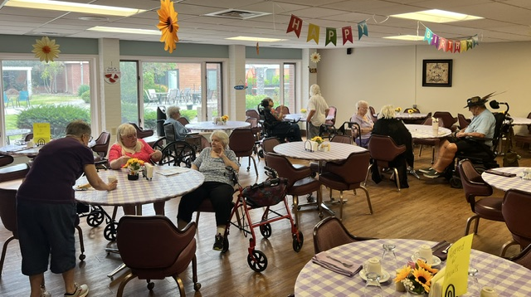  September 2026 |   Maintenance & Housekeeping Messages  The heavy wildfire smoke season has passed, and the filters have been changed. As we move toward the end of summer, we plan to apply another weed-and-feed treatment next month to help improve the grass. Mike has moved on to a new opportunity for himself and his family. We wish him the best and thank him for his hard work during his time here. We will begin looking for a replacement as soon as possible. Communication has improved, but please remember to leave Adam your unit number and phone number when calling or leaving a message so he can respond more quickly. Cottage residents should also remember to carry their front door key when going out during the fall and winter months, as power outages can happen unexpectedly in the Pacific Northwest.  A Look Back at August Activities  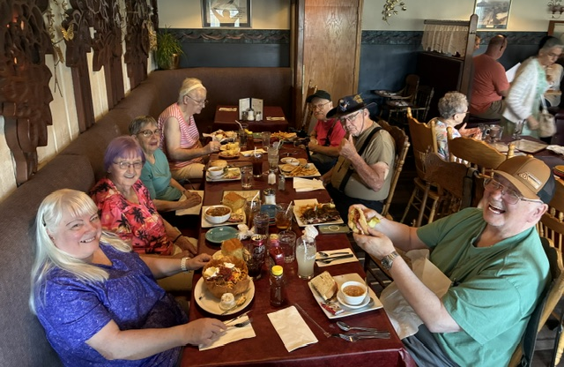  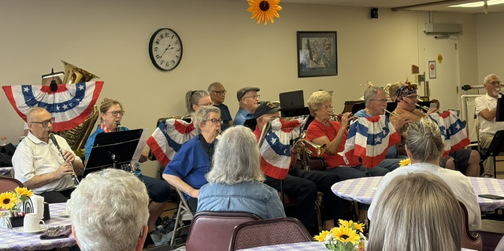  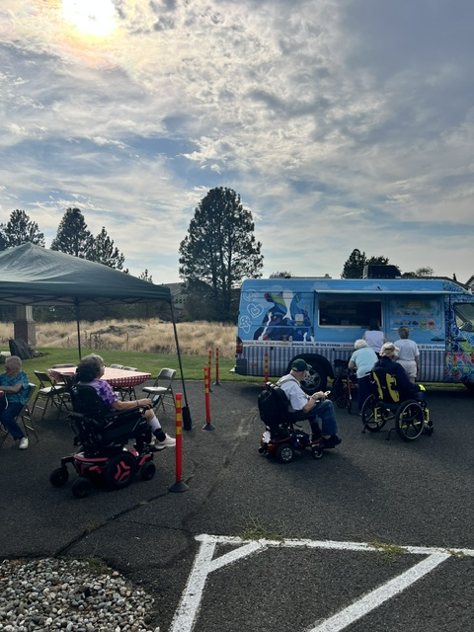 |  | Olympus Living of Spokane Valley
 |  |  | 17117 E 8th Ave. Spokane Valley, WA. 99016 | 509.936.3923 |
 |  |  | Celebrating September  Birthdays  Linda B.  September 3  Elaine H.  September 4  Susan B.  September 5  Dottie N.  September 9  Arvilla N.  September 14  Jack B.  September 17  Jerald M.  September 26  Gretchen A.  September 28 | CEO Message from Rob  Hello everyone! It has been an exciting few weeks as I have gotten to know you and learn of the adventures and challenges that the community has experienced. It is clear that we are not just a collection of cottages and apartments; we are a community of caring people who look after each other and want the best for each other.  I see great things happening in our community. We have started important discussions and through those I have learned what this community values and prioritizes; including groundskeeping, maintenance requests and the dining experience. We are actively moving things forward, and I ask you for patience as we work through the growing pains. In the real near future, we hope to have a "Grand Spouting", to celebrate the restarting of our fountain in the pond. I hope you join us for this joyous event.  In other news, we have several new residents moving into the tower, cottages, as well as the assisted living wing this month. If you see new neighbors around, please offer them a big welcome, just as you have done for me. I hope you are as excited for the future as I am, and I look forward to the great opportunities that are here at Olympus at Spokane Valley.  One and Done  Fun fact-September 25 is One-Hit Wonder Day, a day for us to remember all those musicians who wrote one hit song that dominated the charts and then were forgotten. Perhaps one of the best-known one-hit wonders is “Earth Angel,” the Penguins’ 1954 doo-wop classic. With sales estimated at more than 10 million copies, it is often cited among the most successful one-hit wonders of all time. But don’t take our word for it. Every decade has had its share of one-hit wonders: 1963’s “Wipeout” by the Surfaris, 1977’s “You Light Up My Life” by Debby Boone, 1983’s “Puttin’ on the Ritz” by Taco, 1991’s “Walking in Memphis” by Marc Cohn, and the 2005 hit “Listen to Your Heart” by D.H.T. If you don’t recall any of these songs, you’re not alone, but that doesn’t bother Steven Greenberg, who in 1980 wrote the song “Funkytown.” When asked about his sole hit, Greenberg says, “I call it ‘one-hit wonderful.’”
  September 2026 |  |  | September 2026

